## Use Case Diagram

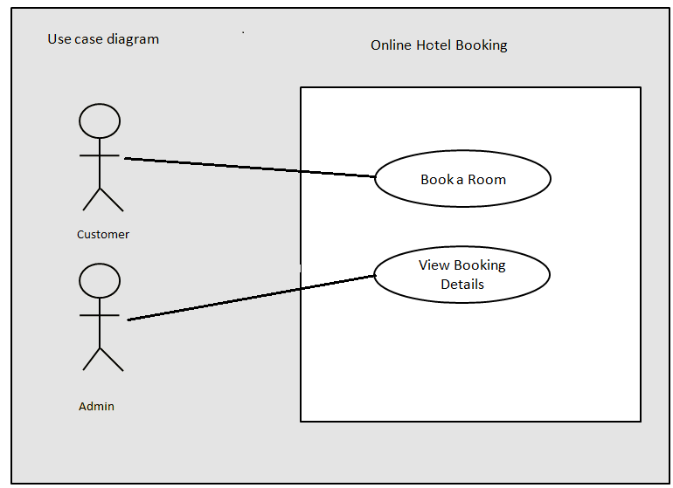

**Requirement 1 (Booking a Room)**

## UI Prototypes Design Requirements

**Note: The HTML page colors and design provided here is just for reference. Associates are free to use any color of their choice.**

#### Screen 1(index.jsp)– Index Page

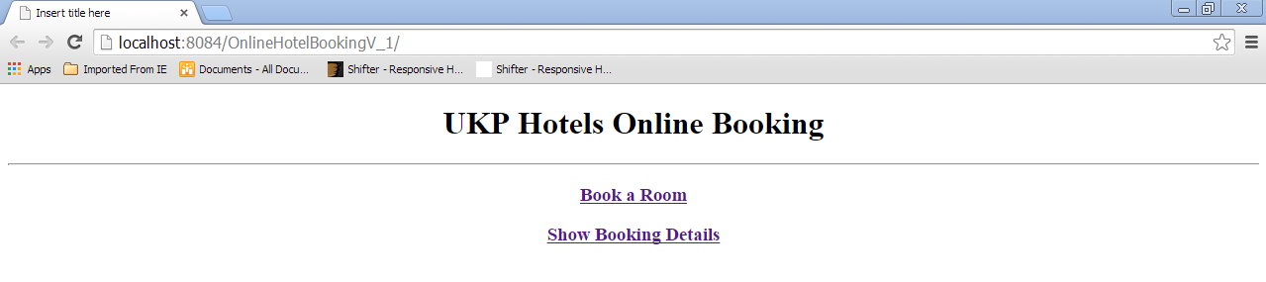

##### UI Design Considerations / Requirements

* Create the links “Book a room” and "Show Booking Details"

#### Screen 2(booking.jsp) –Book a Room

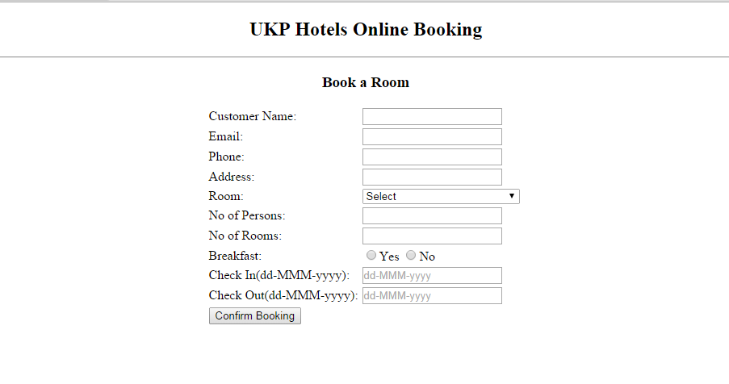

#### On Page Load

##### Business Rules

* None of the fields should be empty
* Customer Name should contain only alphabets and space. Its length should be minimum 2 and maximum 30 characters.
* Email address should be valid
* Phone must be 10 digits only
* checkIn date should be greater than current date.
* checkOut date should not be less than checkIn date.
* All the datatype validation for the form fields should be done.Error message need to displayed to the associates for invalid dataype entered.
* The mandatory condition needs to be checked when user clicks “**Confirm Booking**” button

##### UI Design Considerations / Requirements

* Alignment should look similar as provided in the design
* Rooms should be dynamically populated to the booking.jsp page.

|  |  |
| --- | --- |
| Key | Value |
| "A/C Executive Double Room" | "A/C Executive Double Room" |
| "A/C Deluxe Double Room" | "A/C Deluxe Double Room" |
| "A/C Suite" | "A/C Suite" |
| "Dormitory" | "Dormitory" |

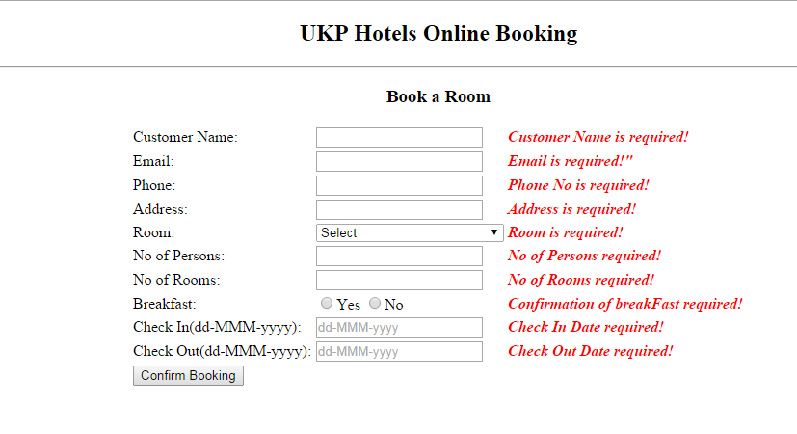

#### Validation failure of all the fields

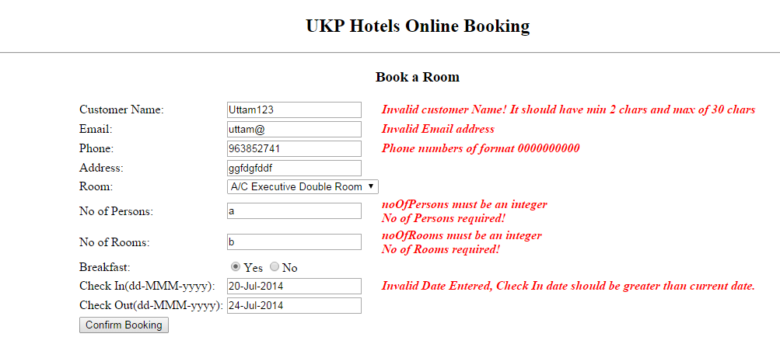

#### On Validation failure of some of the fields

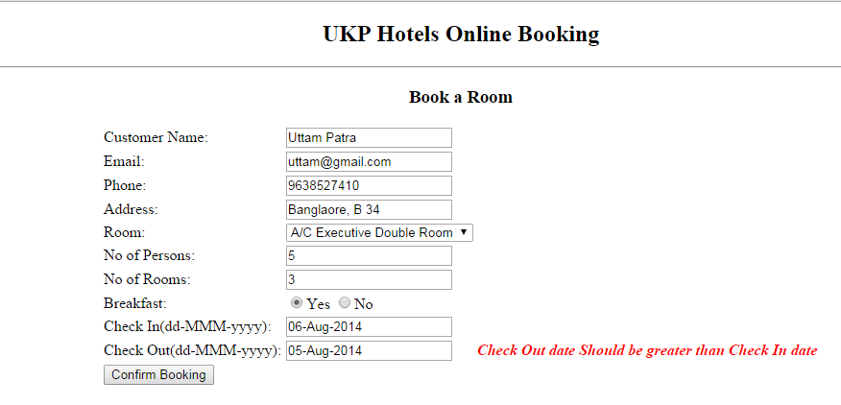

#### On Validation failure of some of the fields

#### Screen 3(bookingSuccess.jsp) – Booking Success

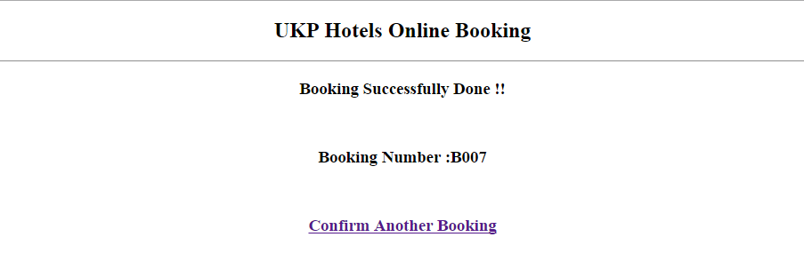

##### Business Rules

* Booking Numbershould be automatically generated on successful booking.

##### UI Design Considerations / Requirements

* Booking Number should be displayed for successful booking
* On click of “Confirm Another Booking” link, the application should take the user to “booking.jsp”

**Requirement 2(Listing Booking Details)**

#### Screen 4(bookingDetails.jsp) –Show Booking Details

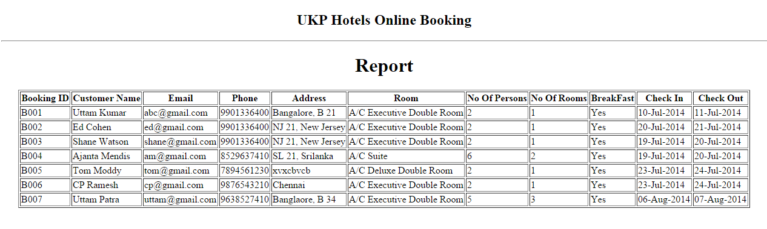

#### On Page Load

##### Business Rules

* Display the list of booking details for the all the CA Enablement Assessments

##### UI Design Considerations / Requirements

* checkIn date and checkOut date should be in "dd-MMM-yyyy" format.